

ANU Metadata Store

NLA Party Identifiers

Web Interface User Manual

.

Contents

Overview 3

License 3

Acknowledgement 3

Trove and the National Library of Australia (NLA) Party Identifier 3

ANU NLA Party Identifier System 3

Features at a Glance 4

ANU NLA Party Identifier Web Interface 4

System Requirements 4

Accessing the Web Site 4

Page Layout 5

Logging in 6

Home Page: 6

Edit Researcher Profile 7

Update the NLA ID 10

Search Function 11

Additional Feature 12

Add Publication records using BibTex formatted Data 12

View the profile of other researchers: 14

View the detailed information of each topic: 15

Glossary of Terms 15

# Overview

This document explains how to use the NLA Party Identifier as a User after it has been implemented, as per the -System Administrator’s manual.

# License

The use of the ANU Metadata Store is governed by the GNU GPL3 license.

# Acknowledgement

This project is supported by the Australian National Data Service (ANDS). The Australian Government through the National Collaborative Research Infrastructure Strategy Program and the Education Investment Fund (EIF) Super Science Initiative supports ANDS.

# Trove and the National Library of Australia (NLA) Party Identifier

The *Trove* party infrastructure (<http://trove.nla.gov.au/>) was developed by the National Library of Australia as the People Australia Infrastructure to support the persistent identification of people or organisations.

The core aim of the Project was to adapt the National Library’s People Australia infrastructure so that the research sector could contribute and manage their party records and obtain NLA-issued persistent identifiers for their records about researchers and research organisations

The solution as provided through the party infrastructure is:

* One unique identifier for every party, issued by the NLA (e.g. Dr Tim Flannery-

<http://nla.gov.au/nla.party-635340>)

In summary, the NLA Party Identifier (NLA ID) is:

* A public identifier.
* A persistent identifier.
* Managed in the public domain.
* Using public information.
* And is available in the NLA’s free public interface Trove

For more detailed information, please see the following links:

* <http://ands.org.au/guides/ardc-party-infrastructure-awareness.html>
* <http://ands.org.au/training/trove/>

# ANU NLA Party Identifier System

This ANU NLA Party Identifier System has been implemented primarily for maintaining the identity information for ANU researchers, and to store their personal information such as their biography, full name, job title, phone number, fax, fields of research etc.

The system is integrated with OAI-PMH (Open Archive Initiative Protocol for Metadata Harvesting (OAI-PMH) technology as a mechanism for interoperability between systems.

In addition, the system enables the creation and harvesting of the NLA ID from the Trove party infrastructure. Below is the NLA ID Minting workflow diagram:



**Figure 1. NLA ID Minting Workflow**

# Features at a Glance

The system has these following features, but not limited to:

* Store and display parties’ information.
* Facilitate the workflow to allow people to update their personal information published for public view.
* Share records with other systems, for example: with the NLA Trove Application.
* Enable user to transfer the NLA ID information to via the web interface.
* Enable user to insert publications records to the system using the *bibtex* input data.
* View the relevant *research topics* associated with each person and search for the people who do research on particular research theme.

# ANU NLA Party Identifier Web Interface

## System Requirements

Accessing the Metadata Interface requires the following software on the user's machine:

* A compatible web browser: the desktop variant of Google Chrome is recommended. Mozilla Firefox can also be used.

## Accessing the Web Site

Type <http://dc7-dev2.anu.edu.au/anu_template/page_login.php> in the address bar of your web browser and press Enter. The home page similar to the one below will appear:

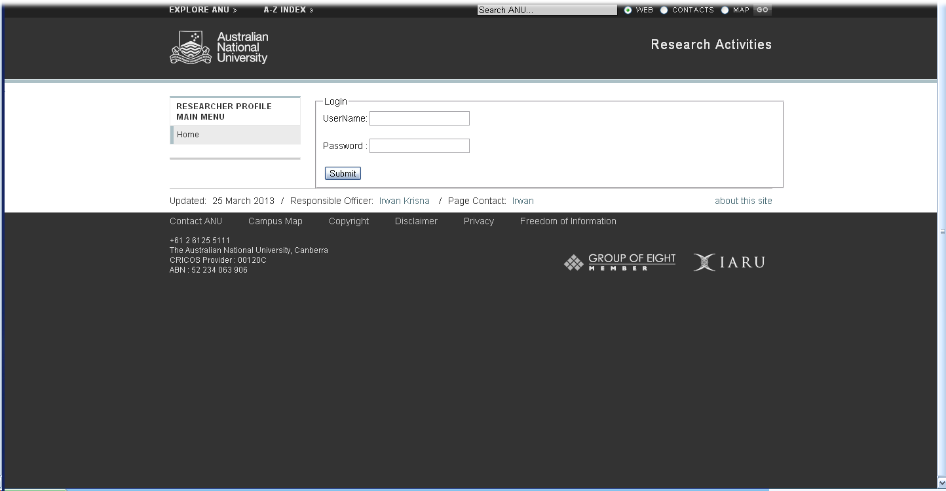

## Page Layout

The NLA Application Identifier uses standard ANU style sheets. All pages in the system will look similar to the page below and contain similar layout elements:

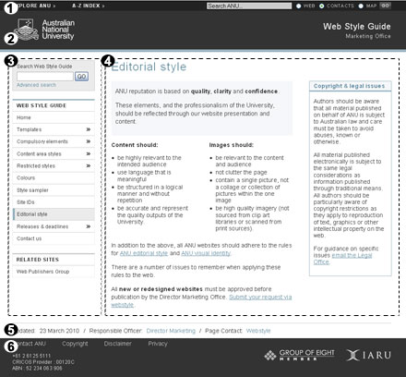

1. Explore bar
2. Site banner
3. Menu area
4. Content area
5. Site footer
6. ANU footer

**Main Page:**



## Logging in

To log into the system, the user need to contact the system administrator to discuss your access requirements.

Enter the relevant user name and password on the screen that follows. Once you've logged in the home page should identify you by your display name. The menu area may list additional tasks that can be performed depending on the permissions assigned to the user in the system.

Contact your System Administrator to request a change to your permissions, if required.

## Home Page:

* **For Researcher** :
* The Home page displays the general information of researcher which includes:

|  |  |  |
| --- | --- | --- |
| **No** | **Field Name** | **Description** |
| 1. | **Fields of Research (FoR)** | The Australian and New Zealand Standard Research Classification (ANZSRC) is the collective name for a set of three related classifications developed for use in the measurement and analysis of research and experimental development (R&D) undertaken in Australia and New Zealand. |
| 2. | **ANU Staff University ID** | For example: u9999999. |
| 3. | **Research Topic** | A topic that generated from a probabilistic model that automatically learns a set of topics (categories) that describe a collection of documents, based on the words in those documents |
| 4. | **De-identified Staff ID**: | To maintain individuals privacy , the application uses the de-identified staff ID as the unique identifier  A concatenation of letter “I” (Internal) and ARIES Staff ID. For e.g.: I8989. |
| 5. | **National Library of Australia Identification (NLA) ID:** | A public identifier issued by the National Library of Australia |
| 6. | **Job Title** | As appeared in the LDAP system |
| 7. | **Title** | For example: Mr, Dr, Professor |
| 8. | **First Name** |  |
| 9. | **Last Name** |  |
| 10. | **Address** | The work address |
| 11. | **Email Address** | The work email address |
| 12. | **URL** | “*Researchers*” web address |
| 13. | **Telephone** | The work phone number |
| 14. | **Fax** | The work fax number |
| 15. | **Scopus Author ID** | Scopus Unique Author ID |
| 16. | **List of Publications** | Publication records from ARIES |
| 17. | **List of Grants** | Grant records from ARIES |

## Edit Researcher Profile

1. **Insert or Update Information**

The web application provides the capability for the researchers to update their personal information by clicking the “**Edit Researcher Profile**” button on the main menu.



1. **Confirm Information**

After inserting or updating the required information, the user may confirm the information by clicking the “Confirm” button as presented below.



1. **Finalize Information**

In order to publish the personal information and let the Trove application to harvest the information, the user is required to finalize the information by clicking the “Finalize Profile” button.



1. **Finalized profile:**



1. **View OAI-PMH records feed:**

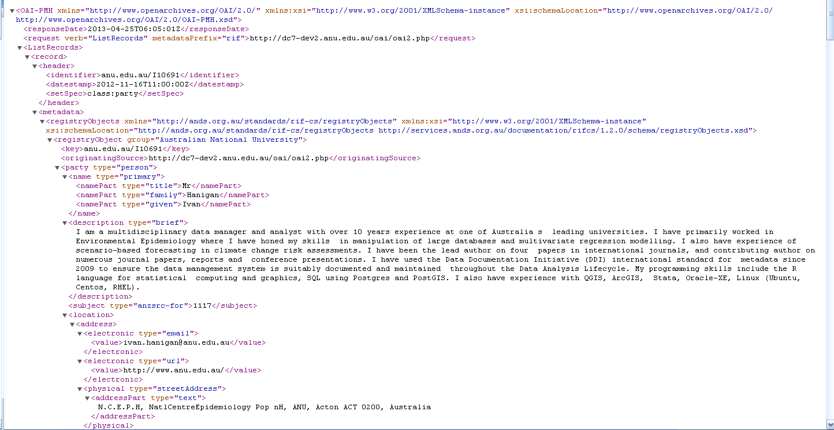

## Update the NLA ID

Once the NLA ID has been generated and stored in the MySQL database, the system also enable the admin user to transfer the NLA ID to the Metadata store system. The following are the steps:

1. Log in as **admin user** (please ask the administrator for the access).
2. Search for the person’s record.



1. In the search result, click on the Update the NLA ID button.



1. See the update result.



## Search Function

Once logged in, a user can do a search for a person or topic as per following:

1. **Search for People**:

A user may search a person based on the university id , first name, last name.

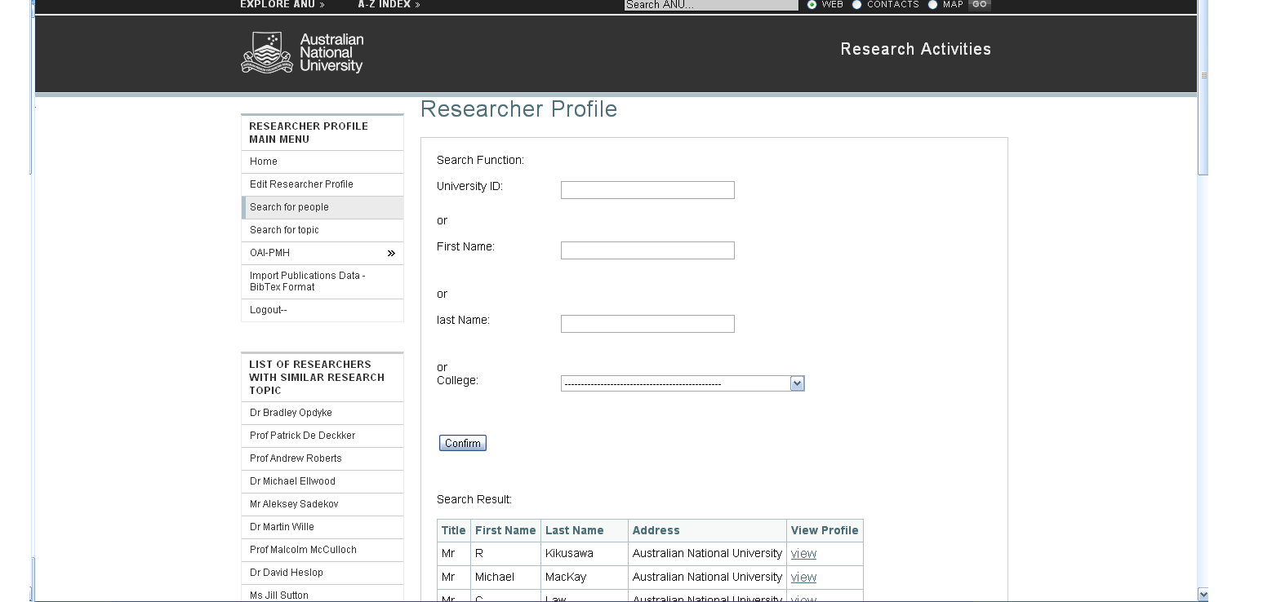

1. **Search for topic**:

A user can search relevant topic based on a keyword:

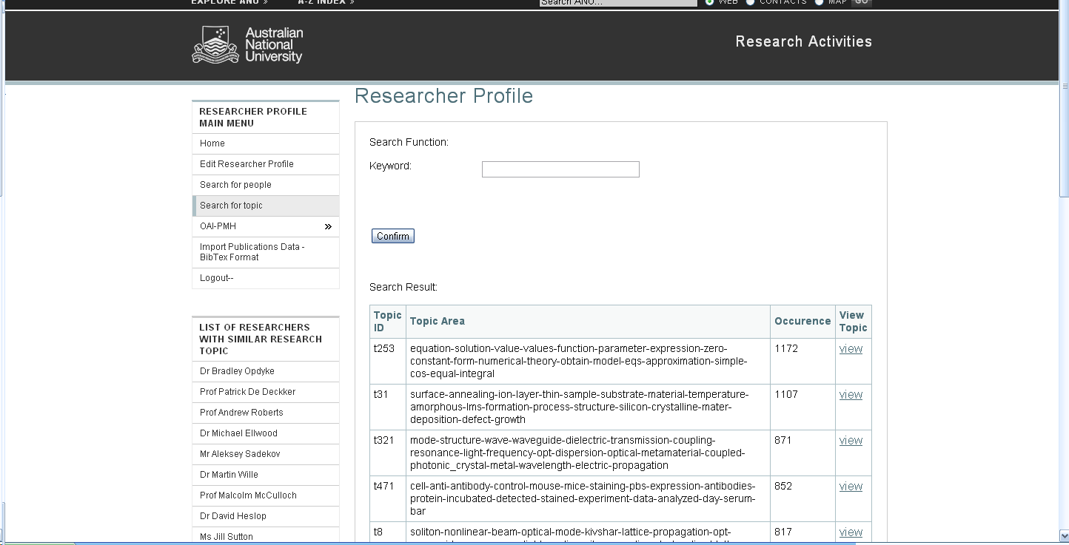

## Additional Feature

## Add Publication records using BibTex formatted Data

The application allows the user to insert publication records using the *BibTex* formatted data.



**Add Publication records using bibTex data:**

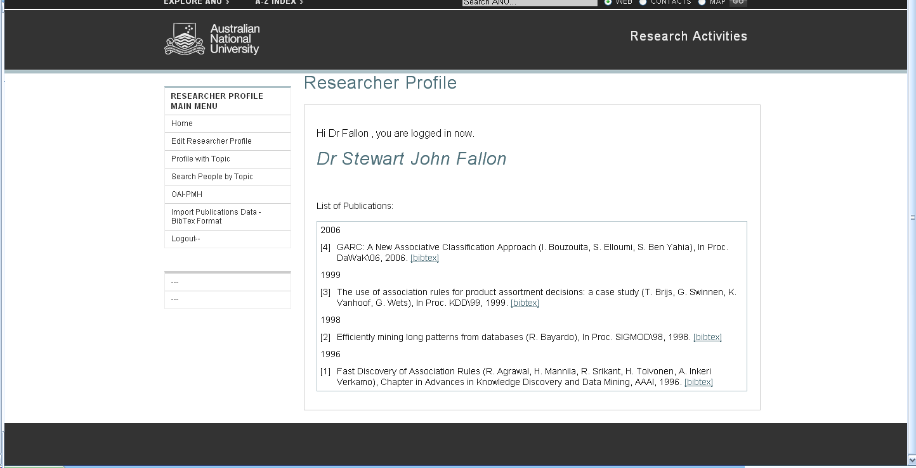

## View the profile of other researchers:



Profile of other researchers:



## View the detailed information of each topic:

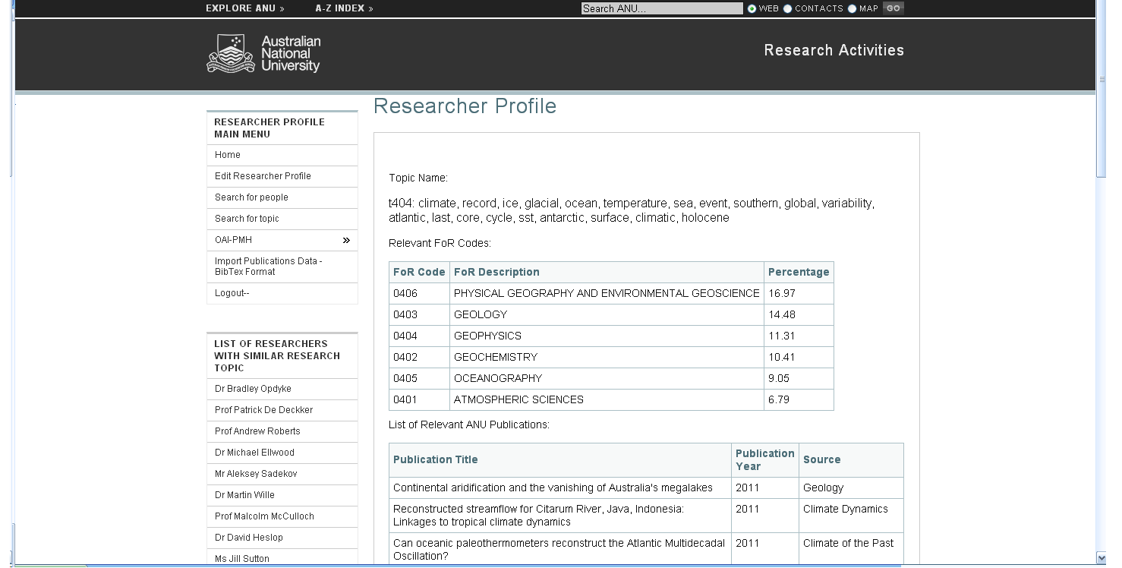

# Glossary of Terms

|  |  |  |
| --- | --- | --- |
| **No.** | **Term** | **Description** |
| 1. | Party |  |
|  |  |  |
|  |  |  |
|  |  |  |
|  |  |  |
|  |  |  |